**1.**

**Source code :**

|  |
| --- |
| // source code 의 폰트는 Courier10 BT Bold으로 하시오  import numpy as np  import random  from sklearn import datasets  import matplotlib.pyplot as plt  def SIGMOID(x):  return 1/(1+np.exp(-x))  # SLP function #########################################  def SLP_SGD(tr_X, tr_y, alpha, rep):  #initialize w  n = tr_X.shape[1] * tr_y.shape[1]  random.seed= 123  w = random.sample(range(1,100), n)  w = (np.array(w)-50)/100  w = w.reshape(tr_X.shape[1],-1)  # update w  for i in range(rep):  for k in range(tr_X.shape[0]):  x = tr_X[k,:]  v = np.matmul(x, w)  y = SIGMOID(v)  e = tr_y[k,:] -y  w = w + alpha * np.matmul(tr_X[k,:].reshape(-1,1), (y*(1-y)*e).reshape(1,-1))  error[i] = np.mean(e)  print("error",i,np.mean(e))  return w  for alpha in [0.05,0.1,0.5]:  ## prepare dataset #####################################  iris = datasets.load_iris()  X = iris.data  target = iris.target  # one hot encoding  num = np.unique(target, axis=0)  num = num.shape[0]  y = np.eye(num)[target]  error = np.zeros(1000) # error 저장할 행렬  print(f'alpha : {alpha}')  ## Training (get W) ####################################  W = SLP_SGD(X, y, alpha=alpha, rep=1000)  ## Test #############################################  pred = np.zeros(X.shape[0])  for i in range(X.shape[0]):  v = np.matmul(X[i, :], W)  y = SIGMOID(v)  pred[i] = np.argmax(y)  print("target, predict", target[i], pred[i])  print(f"final_accuracy[alpha:{alpha}] :", np.mean(pred == target))  ##show error change#############  plt.plot(error)  plt.title('model error')  plt.ylabel('error')  plt.xlabel('rep')  plt.show() |

**실행화면 캡쳐:**

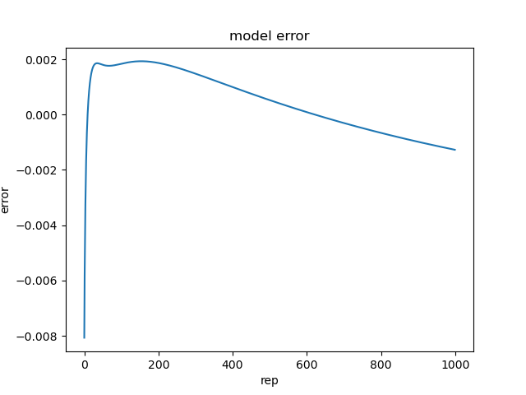



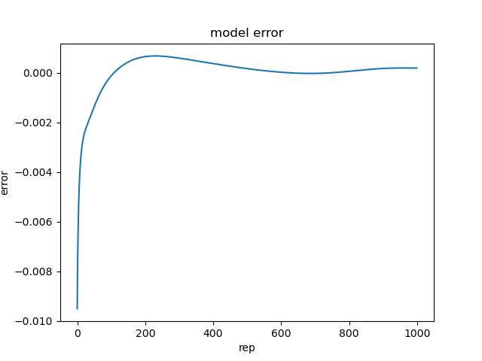



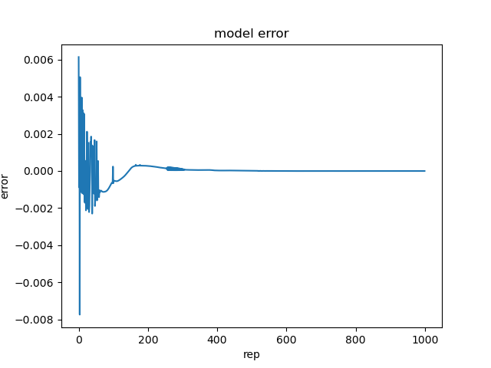



**2.**

**Source code :**

|  |
| --- |
| // source code 의 폰트는 Courier10 BT Bold으로 하시오  ## SLP_SGD , SIGMOID 함수 코드 동일  for rep in [200,400,600]:  ## prepare dataset #####################################  iris = datasets.load_iris()  X = iris.data  target = iris.target  # one hot encoding  num = np.unique(target, axis=0)  num = num.shape[0]  y = np.eye(num)[target]  print(f'repeat : {rep}')  ## Training (get W) ####################################  W = SLP_SGD(X, y, alpha=0.01, rep=rep)  ## Test #############################################  pred = np.zeros(X.shape[0])  for i in range(X.shape[0]):  v = np.matmul(X[i, :], W)  y = SIGMOID(v)  pred[i] = np.argmax(y)  print("target, predict", target[i], pred[i])  print(f"final_accuracy[repeat:{rep}] :", np.mean(pred == target)) |

**실행화면 캡쳐:**





